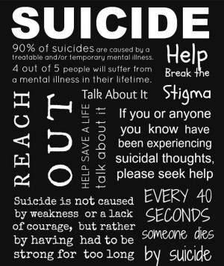Suicide is not the solution

**Suicide** becomes a strong and big evil of our society, especially in today's generation. Every next person facing problems try to commit suicide. It's not a easy step , requires a lot of courage for this but no matter how harsh the situation is ; how hard the life is , suicide is not the answer. Try to avoid such type of negative thoughts of self harm and self destruction. Always think positively and find solution of problems because there is a solution of every problem but suicide is not the one.

**Who are at the risk of suicide?**

1. Those who failed in any exam or in any project are try to commit suicide.
2. People suffering from depression and anxiety
3. People who failed in their relationship
4. Those who try to commit suicide before or expressed the idea of self harm or ending their lives
5. Youth and children addicted to dangerous mobile games

**How to overcome with suicidal thoughts?**

* **Share your feelings**

Start sharing your feelings with someone who you trust, whom you think can understand you. When you share your thoughts, your feelings, it gives you relaxation. Otherwise you feel suffocate, your own thoughts start pressurising yourself. And force you to take some harsh steps . So its better to share with someone. This will make your mind refresh and make your problem a little small.

* **You deserve to live**

Never thought that you don't deserve a life to live. Life is full of ups and downs but it doesn't mean that you give up on them. No one is their who have only happiness in his life. Everyone faces problems. And you see that some people are enjoying the problems of life. Because life becomes boring if there is only happiness in it . So try to face those problemas **“ITS JUST A TIME THAT WILL ALWAYS PASS AWAY” .** You have a life to live and enjoy don't end it for those problem which are temporary. You have a life because you deserve it.

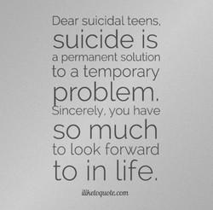

* **Think about those who loves you**

When you have these kind of bad thoughts think about your mom who bears so much pain to give you birth and wants to see you always happy and healthy , your father who sacrifice all his wishes to make you a good person and always tries to fill your life with lots of love and happiness , your friends who always there for you ; always support you encourage you and all the other persons who wants you to stay healthy and happy in your life. How bad they feel with you decision of self harm. Thinking about the people who care for you gives you strength to face problems and fight back with it.

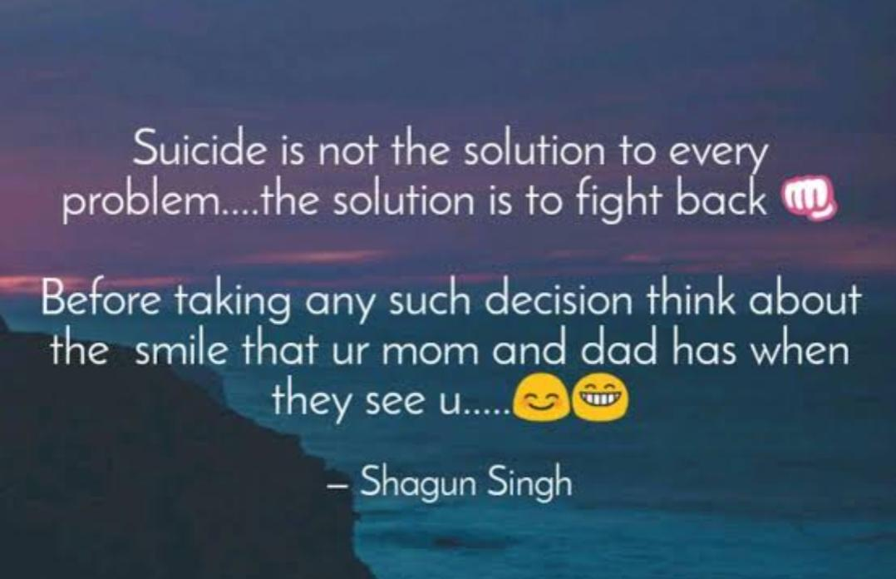

* **Always think positively**

Every situation has two sides – positive and negative. So always try to take out the positive side. Negative thoughts easily captures your mind but try to avoid them. They paved the way to the thoughts like suicide and self harm. Positively is one of the best ways to live and enjoy a life .

* **Have self confidence and self belief**

Always have belief in yourself. Never feel depressed or disheartened when someone says anything bad to you. You know yourself. It doesn't matter what other think about you what matters is what you think about yourself. Having faith in yourself helps you to understand the value of your life.

Life is strange and weird for everyone. You just need learn how to enjoy and be happy in every situation of life. Always try to find solutions of problems, never give up on them . Suicide , self harm or self destruction is not the answer to any problem. You have a life so live it , enjoy it . Try to be satisfied with your life, don't try to grasp everything as it is not actually possible. Every life is very precious, so respect the life that you have and stay healthy , safe and happy.